**Setup of Apple Watch with Gfit**

**The following instructions will guide you through registering your Apple Watch with the Gfit app and then you can get registered with Cure Science at** [**appomics.org**](https://appomics.org/)**.**

**Before setup:**

* **Always wear the Apple Watch properly on your wrist.**
* **Please wear your Apple Watch throughout the day so that all data can be recorded Incomplete data will not be useful for analysis.**
* **Please always keep your Apple Watch connected with the Apple Health app on iPhone which will communicate using Bluetooth /WiFi. This is required for proper syncing of the data with the Apple server which will receive the data.**
* **Be sure to open your Apple health app and Gfit app at least once daily to allow the data to sync with the app and server.**

**Step 1: Google fit app installation**

**Install Google Fit app from iPhone App store. You can use the following link :-**

[**https://apps.apple.com/in/app/google-fit-activity-tracker/id1433864494**](https://apps.apple.com/in/app/google-fit-activity-tracker/id1433864494)



**Login with your Google account username(email) and password in the Gfit app.**

**Step 2: Sync data with Google fit App**

**1.** **Tap on the ‘profile icon’ in the top right corner of Gfit app window (shown with arrow below).**

1

**2. Tap on Settings:**

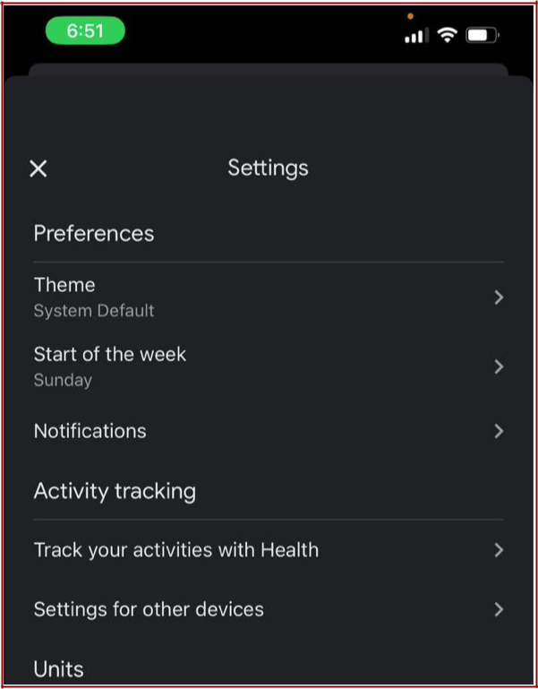

**3. Tap on Activity tracking with apple health app**

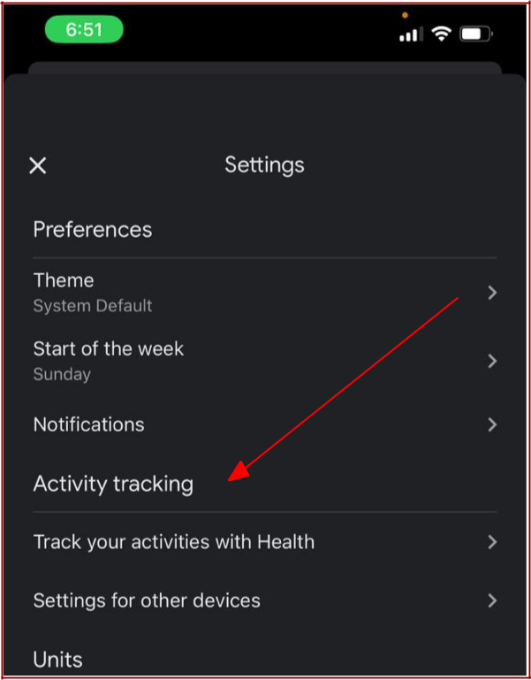

2

**3. Turn on “Connect with Google Fit with Apple Health” (shown with arrow below)**

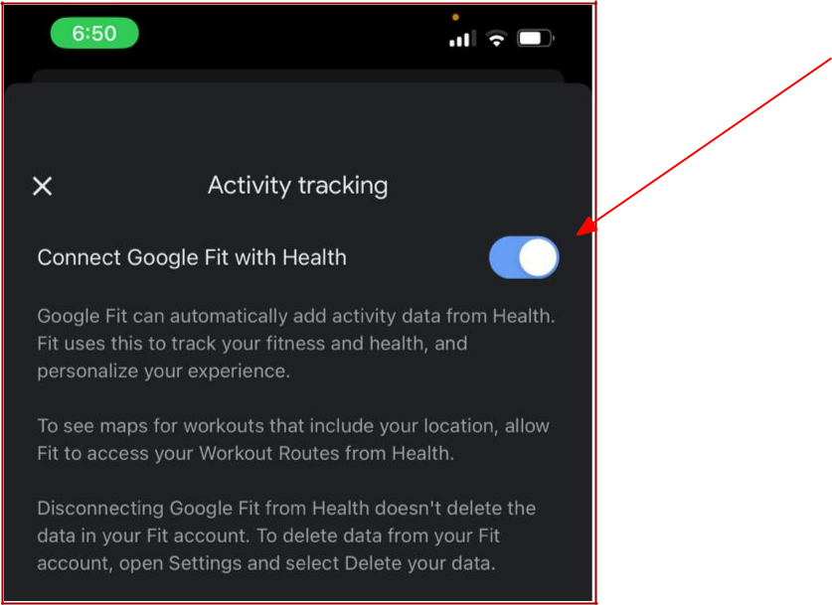

**Step 3: Register with CureScience**

**During this step you will set up your Apple Watch to share data with the CureScience server.**

**To register with CureScience, open the following link in a web browser and follow the instructions to register.**

<https://appomics.org/Wearables>

**Please ﬁll the required information in the form and click on the “Google Fit” option to get registered.**

3

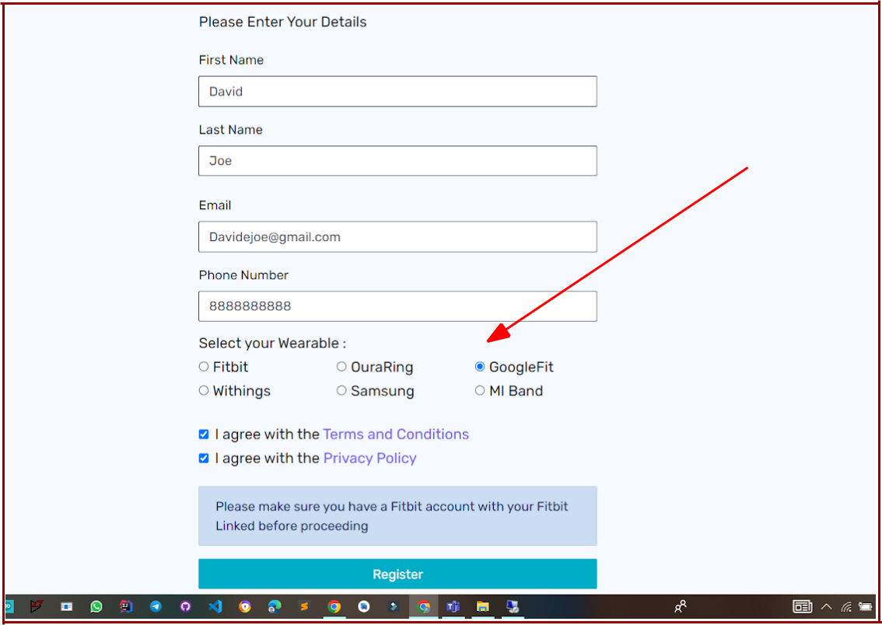

**After you click on the register button you will be directed to login with your Google account.**

**[Note: Please register with the same Google account credentials username and password that you used in the Google Fit app on your iPhone].**

**Select the email account which you previously linked with your Google Fit app username and password.**

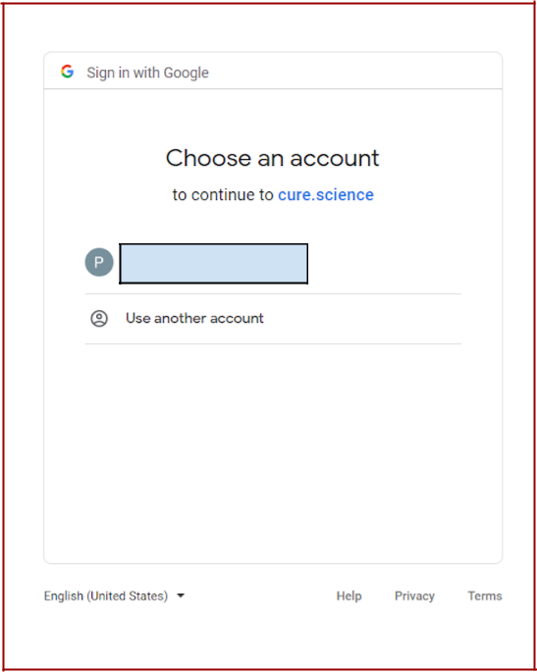

4

**Click the “Advanced” option and you will be redirected to the page as shown below.**

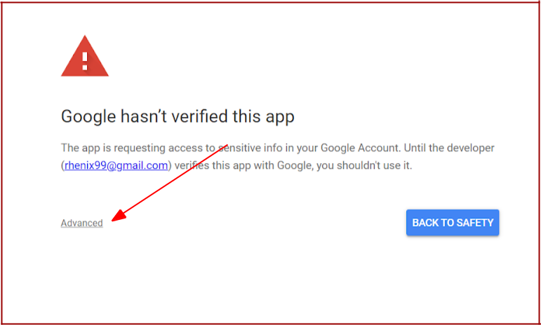

**Advanced Setting**

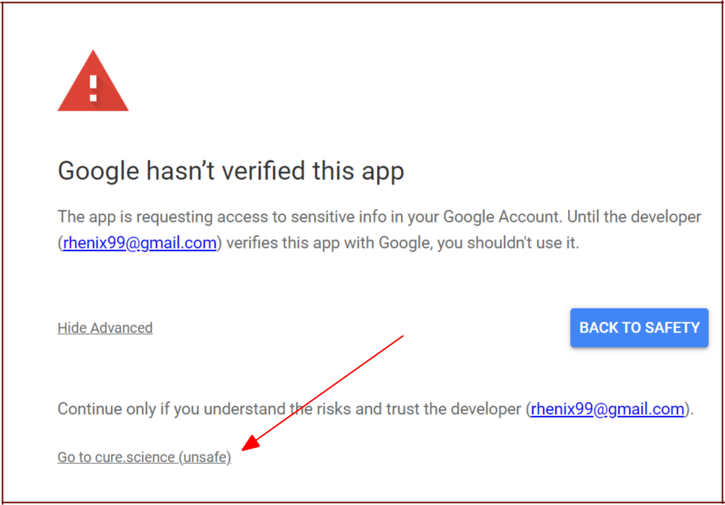**Once you are taken to the Advanced option click on “Go to the cure.science” option and you will be redirected to another page.**

5

**Note: [Please ignore the “unsafe” warning].**

**Please select / check all options checkboxes and then click continue.**

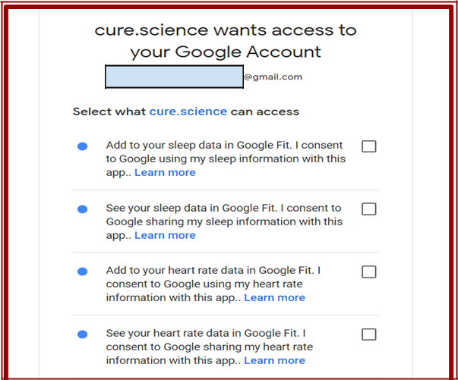

6

**Once your registration with is complete you will see the message show below.**

**Note: Please remember to open your Apple Health app and Gfit app at least once daily and connect to Bluetooth/ WiFi so that the data will be synced with the**

**apps and the server**

**Thank you for completing your registration !**

7